**Alm lab Automated MoBio 96-Well Extraction Method for**

**EpMotion 5075 (Rosie)**

Notes:

* Rosie will require user to enter the volume for each plate and reservoir before the actual run will begin (or you can just load the required volume and hit Ok each time she asks)
* Heat water bath to 65C before starting
* Reservoir volumes are noted in the protocol
* For plate volumes enter the minimum indicated
* For reagent volumes enter in the appropriate volume
* All centrifugation steps are at 3220g on Alm lab Eppendorff centrifuge or ideally at 4500xg if possible. Times have been increased to accommodate for slower spin in the Alm lab, if able to spin at 4500xg decrease time by three minutes

Things you will need:

1. 1200uL 8-channel Rainin pipete + 8 boxes of tips (#RT-L1000XF)
2. 7 boxes of EpT.I.P.S. motion 1000uL filter tips [#960050029]
3. one box (partial box) (96) EpT.I.P.S. Motion 300uL filter tips
4. Ice + container large enough to fit two plates
5. 5_100mL Eppendorf sterile reagent reservoirs (#960051017)
6. 2_100mL Eppendorf sterile reagent reservoirs (#960051009)
7. 2 Axygen 2mL deep well plates (for cultures, Cat# P-DW-20-CS)
8. The following plates from the extraction kit (2 minimum, Mobio #12955)
   1. 1 Bead plate (2)
   2. 1 Splin plate (filter) (2)
   3. 1 0.5mL collection (2)
   4. 4 1.0mL collection plates (8)
   5. 2.0mL collection plates (2)
   6. 1 microplate (DNA elution) + mat (2)
9. Plate shaker (MoBio #11996) + plate adapters (MoBio #11999)
10. Swing bucket centrifuge (4500xg)
11. 65C/95C water bath (with metal rack for propping up the plate)
12. ProteinaseK (Qiagen Solution Cat# 19133)
13. 100mL pipetting reservoir (for by-hand pipetting during vacuum steps)
14. Autoclaved disposable spatulas (VWR standard (for human samples) #80081-190, micro (for mouse samples) #80081-194)

Before you start:

1. Clean cabinet thoroughly with RNAse Away, followed by 70% EtOH. Allow the cabinet to dry completely
2. UV cabinet for 15 minutes
3. Label plates as follows:
   1. Bead Plate: Bead Plate #A and Bead Plate #B (label mat covers as well)
   2. Spin Plate (filter): SpinPlate#A and SpinPlate#B
   3. 0.5 collection plate: Collection#A and Collection#B
   4. 1.0mL collection plates:
      1. Plate#A-1, Plate#A-2, Plate#A-3, Plate#A-4
      2. Plate#B-1, Plate#B-2, Plate#B-3, Plate#B-4
   5. 2.0mL collection plate: Plate#A-5, Plate#B-5
   6. Microplate: Label with extraction date, plate name
4. Label and fill the first 6 reservoirs (1 30mL and 5 100mL) as follows:
   1. 1A – 4.5mL ProteinaseK (30mL reservoir)
   2. 2A – 73mL Bead solution
   3. 3A – 73mL Bead solution
   4. 4A - 13mL C1
   5. 5A – 50mL C2
   6. 6A – 40mL C3
5. Label and fill the next 6 100mL reservoirs as follows:
   1. 1B – 64mL C4
   2. 2B – 64mL C4
   3. 3B – 64mL C4
   4. 4B – 64mL C4
6. Load samples into 96-well MoBio Bead Plate:
   1. Spin down collection tubes, 3,000rpm for 30 seconds
   2. Suck off RNAlater with pipette
   3. Wash sample with 4mL (1mL if small tubes) PBS
   4. Spin down collection tube, 3,000rpm for 30 seconds
   5. Suck off PBS with pipette
   6. Remove plate mat from desired Bead plate
   7. Use disposable spatulas to scoop out ~250mgs of sample
   8. Load sample into wells sample into desired well and leave spatula in well as marker
   9. When all samples have been placed into bead plate remove spatulas form wells one by one
   10. NOTE – this is a stopping point, once loaded samples can be covered with the square-well mat and stored at 4C overnight.

DNA Extraction – Part 1 of 4:

Note: Bead plates can be centrifuged at max for 1 minute to ease opening of the plates

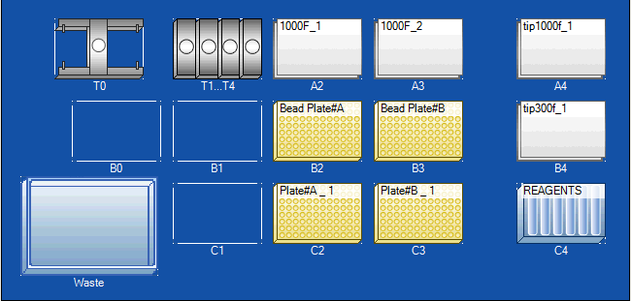

1. Set up worktable according to the figure above
   1. Filter tips in location A2 and A3, non-filter tips A4
   2. Bead Plate#A – B2, Bead Plate#B – B3
   3. Plate#A-1 – C2, Plate#B-1 – C3
2. In reagent rack C4 place reservoirs 1A-6A in appropriate location, indicated by the numbering on the front surface of the rack
3. Uncover reservoirs 1A-4A (ProteinaseK, Bead solution, C1) and remove Bead plate well mat
4. When all items are in place, select run
5. When prompted select Tips only. Locations and levels (already entered) will not be checked therefore it is very important to have the plates, tips, reservoirs and other items in the correct locations (shown above)
6. 20uL ProteinaseK ,750uL of Bead solution, and 60uL C1 will be added to each well
7. Remove Bead Plates. Tightly secure well mat to bead plate
8. Place sealed plates in 65C water bath for 10 minutes
9. Place Bead Plate with well mat securely fastened in the bead Plate Shaker using the following order: aluminum plate, black rubber mat, bottom of plate, top of plate, black rubber mat, aluminum plate
10. Shake at speed 20 for 10 minutes
11. Rotate both plates 180 degrees (so the side of the plate facing you at first is now facing away form you)
12. Shake for another 10minutes at speed 20 – during this time microwave water for “95C H2O bath”
13. Place plates in 95C water bath for 10 minutes
14. Centrifuge for 9 minutes at MAXg
15. During step 14 complete part #1 of method. An aliquot of 250uL C2 will be dispensed into each well of Plate#A-1 and Plate#B-1. Remove form deck once centrifugation of Bead Plates is complete
16. Remove Bead Plate mats
17. Transfer supernatant (700uL) to appropriate Plate#A/B-1 using 1200uL * channel Rainin pipette. Be careful to avoid pellet. Mix by pipetting with each sample transfer
18. Cover with sealing tape and incubate on ice for 10 minutes
19. Centrifuge at MAXg for 20 minutes
20. Go to part 2 of 4

DNA Extraction – Part 2 of 4:

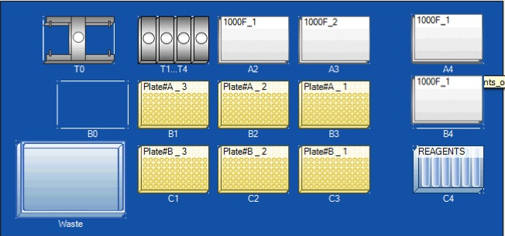

1. Place 100uL filter tips in position B4
2. Set up worktable according to the figure above
3. Remove sealing tape from plates#A/B-1 and place in indicated positions (B3, C3)
4. When all items are in place, select run
5. Approximately 600uL of supernatant will be transferred from Plates#A/B-1 to A/B-2
6. Apply new sealing tape to Plates#A/B-2 and centrifuge at MAXg for 6 minutes
7. Remove cover from reservoir #6 – C3
8. 200uL of C3 will be added to each well of Plate#A/B-3
9. Replace 1000uL filter tips in position A2, A3
10. Carefully remove sealing tape from Plates#A/B-2 and return to positions B2, C2
11. 600uL of supernatant will be transferred from Plates#A/B-2 to Plates#A/B-3 and mixed
12. Apply sealing tape to Plates#A/B-3
13. Incubate plates on ice for 10minutes
14. Centrifuge plates at MAXg for 9 minutes
15. Go to part 3 of 4

DNA Extraction – Part 3 of 4:

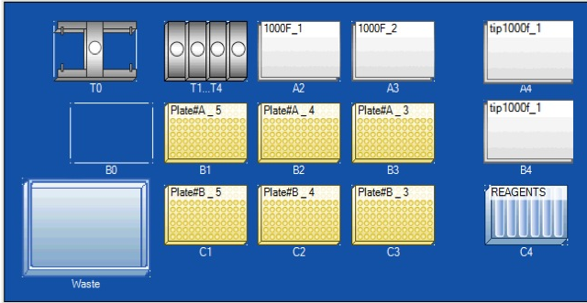

1. Replace filter tips in positions A4, B4
2. Set up worktable according to the figure above
3. Replace reservoirs 1A-6A with 1B-4B
4. Remove sealing tape from Plates#A/B-3 and place in indicated positions (B3, C3)
5. When all items are in place, select run
6. Approximately 700uL of supernatant will be transferred from Plates#A/B-3 to A/B-4
7. Apply new sealing tape to Plates#A/B-4
8. Centrifuge plates at MAXg for 9 minutes
9. Replace 1000uL filter tips in positions A2, A3
10. Remove covers form reservoirs 1B and 2B (solution C4)
11. 650uL of C4 will be added to each well of Plates#A/B-5
12. Remove sealing tape from Plates#A/B-4 and place in indicated positions (B2, C2)
13. Approximately 650uL of supernatant will be transferred from Plates#A/B-4 to A/B-5 and mixed
14. If you wish to continue to the spin plates, uncover 3B & 4B reservoirs press “ok” – 650uLs of C4 will be added to A/B-5 plates
15. Note - You may stop at this step, by covering and storing both plates in 4C
16. Go to part 4 of 4

DNA Extraction – Part 4 of 4 (By-hand Centrifugation Protocol):

1. Place spin plates onto A/B 0.5 collection plates
2. Using the Rainin 1200uL 8 channel pipette, mix by pipetting and then transfer 650uLs form Plate#A/B-5 to SpinPlateA/B and cover with Centrifuge tape
3. Centrifuge for 5 minutes at MAXg, discard flow through and place the Spin plate back onto same 0.5mL collection plate. Discard Centrifuge tape
4. Repeat steps 2-3 twice more.
5. Place the Spin plates back onto the same 0.5mL collection plates
6. Add 500uL of C5 into each well of SpinPlate#A/B
7. Apply centrifuge tape to both spin plates and place back onto the same 0.5mL collection plates
8. Centrifuge Spin/0.5 collection plates at MAXg for 5miuntes.
9. Discard flow through and place spin plates back onto same 0.5mL collection plates.
10. Centrifuge Spin/0.5mL collection plates at MAXg for 5 minutes
11. Carefully place Spin plates onto labeled Microplates. Remove Centrifuge tape and let air dry for 10minutes.
12. Add 100uL of Solution C6 to the center of each well of the Spin plates. Apply centrifuge tape.
13. Centrifuge for 5minutes at MAXg.
14. Remove Centrifuge tape and discard. Plates are now ready for downstream processing, cover wells of Microplates with Elution Sealing Mats provided and store at -20C.